Review/Edit/Approve POC Bypass Tool

Team Leaders will now have the ability to skip “Review/Edit/Approve 485” workflow. This will streamline the 485-review process and get the 485 to the Clinical Reviewers with fewer clicks.

Following a completed start of care visit, Team Leaders receive the following workflow:



Which looks like this when opened:

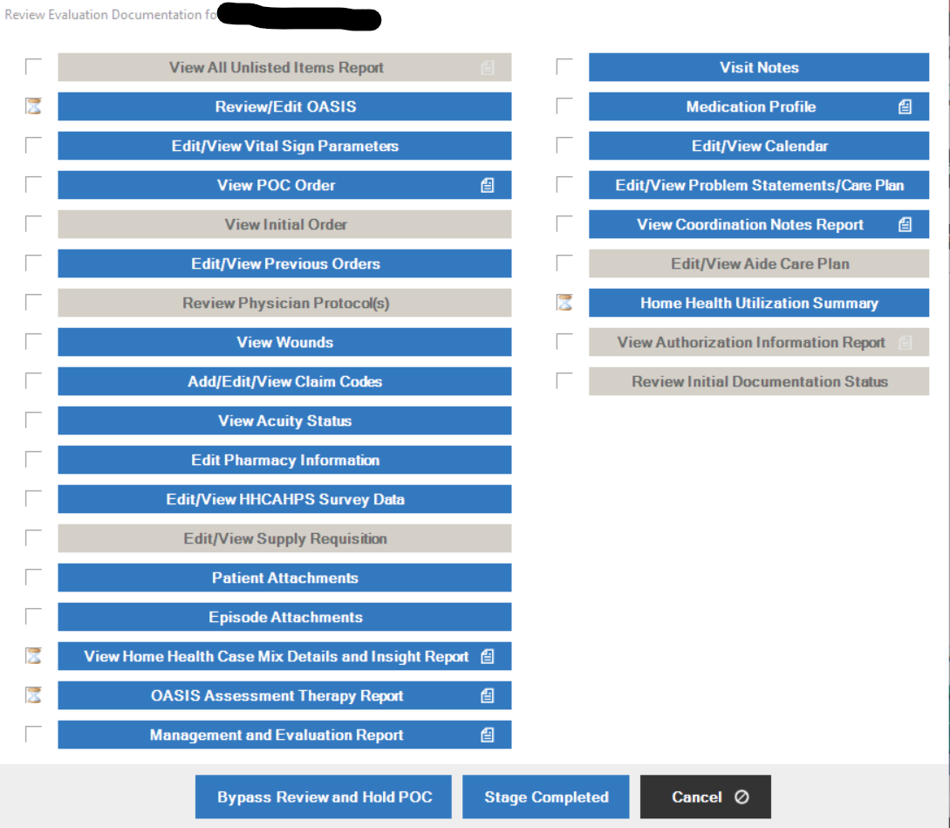

After completing initial review by the Team Leaders, they will then click this button:

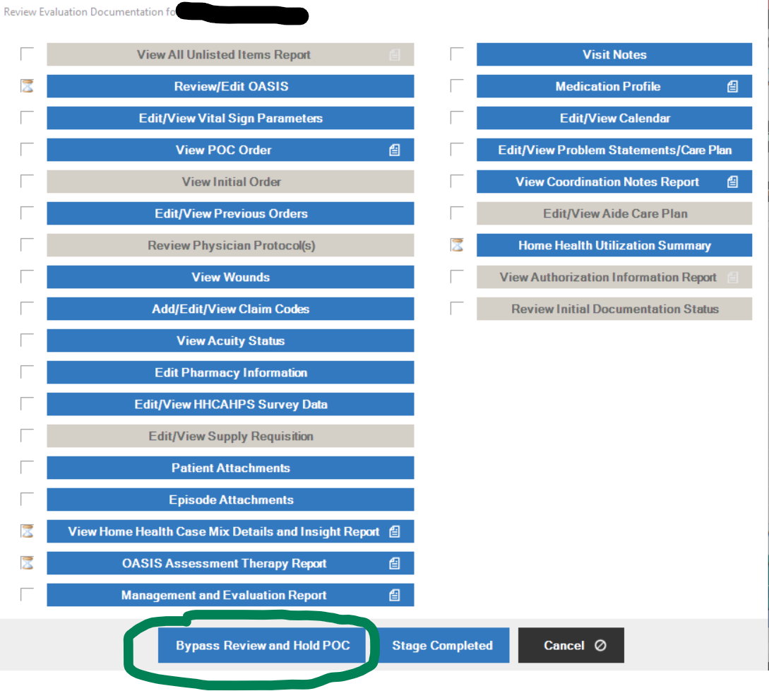

Workflow will then clear from the Team Leader’s workflow and go to the Clinical Reviewer’s “Review/Edit/Approve Held 485” workflow.

**Note:** If Team Leader clicks “Stage Complete” instead of “Bypass review and Hold POC” from the “Review Evaluation Documentation” workflow, they will not skip the “Review/Edit/Approve POC” workflow but will be required to work the workflow instead. Upon completing review/edit/approve POC workflows, they will click “Hold POC for Additional Clinical Review” as before, in order to clear the workflow from the Team Leader and move the 485 review to the Clinical Reviewer so they can begin their review of the POC.

