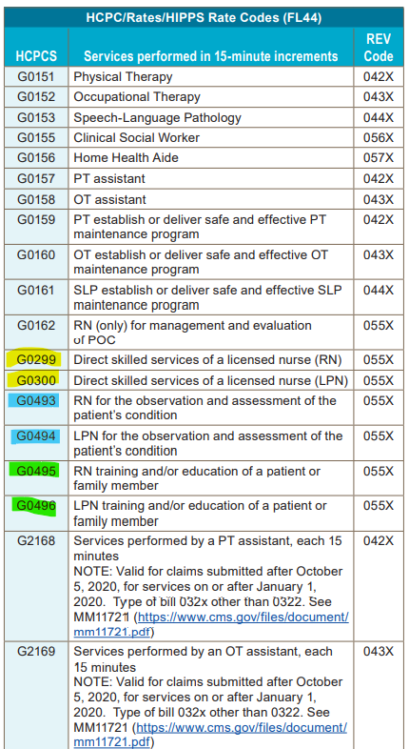

Teaching only being provided, no hands-on care. Very possible this will be the most commonly used G code for nursing.

Used when no hands-on care or teaching being provided, only observing and assessing patient. Can only be used for 21 days.

Hands-on care being provided. Ex: wound care. This is the default code, if no G code changes made within visit, this code that will appear on the claim.

These 2 must manually be selected by the clinician within the visit if needed.

How to choose a different G code within the visit

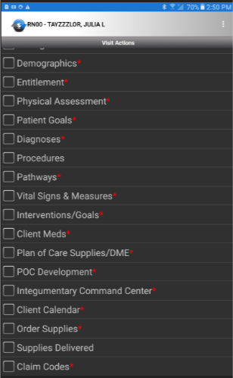If not providing hands on care during visit, and need to choose a different G code for services provided, do the following:

Click Claim Codes

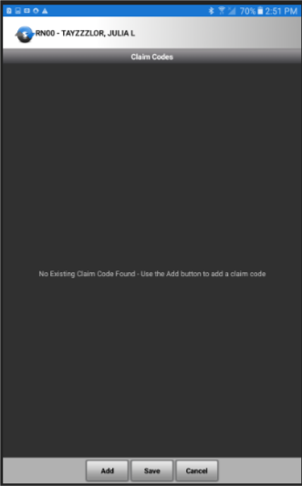

Click Add

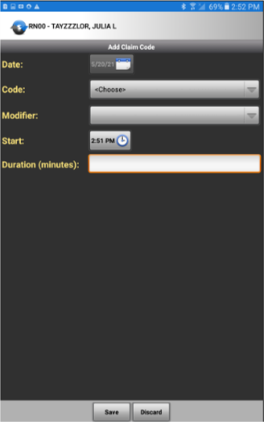

Click the drop-down box beside Code

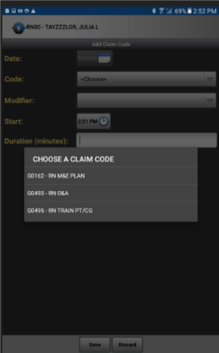

Choose the correct code for the visit.

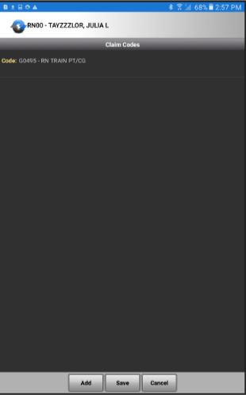

Save

Note: If no G code changes are needed, Click Claim Codes, and just save to complete the checkbox.

Workflow does then go to the Clinical Reviewers, and they will review G code suggestion, to compare to visit to determine if the G code selected is appropriate.