Our plan addresses all five strategic elements, which are the building blocks to QAPI.

**Element 1: Design and Scope**

Our quality assurance and performance improvement is integrated into all care and services that impact clinical care, quality of life, resident choice, and care transitions. We will assess, monitor and improve performance of the following care and services that we provide: clinical/nursing, culinary, housekeeping, laundry, environmental, social services, transportation, programming, therapies, spiritual support and dementia care. Ohio Living Communities aim for safety and high quality with all clinical interventions while emphasizing autonomy and choice for residents (or resident’s agents).

**Element 2: Governance and Leadership**

The people in leadership roles will seek input from facility staff, residents, and their families and/or representatives. They will assure that adequate resources exist to conduct QAPI efforts. Standards are set around safety, quality, rights, choice, and respect by balancing safety with resident-centered rights and choice. The leadership staff ensures staff accountability, while creating an atmosphere where staff is comfortable identifying and reporting quality problems as well as opportunities for improvement. Leadership conveys that being on a PIP team is an important part of the job—not something to put aside if other things come up. They will enable staff to complete daily assignments and also participate on QAPI teams.

**Feedback, Data Systems and Monitoring**

Ohio Living Communities use a variety of data and monitoring systems including: MatrixCare reports, CareWatch data analysis, CMS quality indicators, state and federal survey results, ODA resident and family satisfaction surveys, discharged resident satisfaction surveys, staff satisfaction surveys, internal audit results, external audit results, audit results from CMS and other payers, publicly reported nursing home data and indicators, adverse/critical events and input and feedback from staff, residents, families, vendors, visitors and others. Performance benchmarks are set by each Ohio Living community.

**Performance Improvement Projects** (PIP)

A Performance Improvement Project is a concentrated effort on a particular problem in one area of the facility or facility wide; it involves gathering information systematically to clarify issues or problems and intervening for improvements. The facility conducts PIPs to examine and improve care or services in areas that the facility has identified.

**Systematic Analysis and Systemic Action**

Each Ohio Living community uses a systematic, organized and structured approach to determine whether and how identified problems may be caused or exacerbated by the way care and services are organized or delivered. Each community utilizes Root Cause Analysis (RCA) in determining the reason for a system failure in order to prevent future events and promote sustained improvement.

**Steps to Developing a QAPI Culture**

Step One

Start a QAPI awareness campaign.

* Let everyone know (staff, residents, families, vendors, etc.) about the QAPI plan
  + Use posters, meetings, learning circles and other forms of communications that have worked well in the past
  + Communications should convey the message that QAPI is about system analysis and business practices and that everyone is encouraged to raise concerns about quality especially in high-risk, high volume, problem-prone areas.

Step Two

Each community will develop a QAPI steering committee. The Medical Director, Administrator and Director of Nursing will be appointed as members of the steering Committee. This committee will:

* Complete the **QAPI Self-Assessment tool** using this as a key driver of the plan
* Set PIP priorities
  + When chartering a PIP, careful consideration must be given to the purpose of the PIP and type of members needed to achieve that purpose. Here are some examples:
    - A PIP team with the goal of helping residents go outside more often decided that grounds personnel needed to be on that team so that procedures for snow removal, sun protection, and outdoor seating could be considered.
    - After a PIP team began working on the problem of anxiety among residents, the members realized that many of the affected residents reported reassurance from the pastor and asked the QAPI committee to add him to the team that was planning the approach.
    - A PIP team working on reducing falls asked that the housekeeping department be involved as it considered root causes of falls and realized that equipment in the corridors and clutter in the bathrooms contributed.
* Appoint teams to work on PIPs, review the results and determine next steps
* Encourage frontline staff to participate
* Approve and provide equipment and training needed
* Create a culture of open communication, void of retaliation
* Promote the integration of QAPI into all daily activities and work flows
* Monitor for gaps, patterns and trends for high risk and problem prone areas

Step 3

The steering committee with suggestions and input from staff, residents, families, and vendors, will:

* Decide what data to monitor routinely such as falls, pressure ulcers, antipsychotic medications, complaints from residents and families, re-hospitalizations, resident satisfaction surveys, quality measures, business processes, staff turnover, on the job injuries, etc.
* Prioritize the areas for improvement and charter PIP teams
* Create a dashboard to track the data being measured
* Decide what tool will be used to consistently measure the data.
* Establish the community’s baselines within the data that’s monitored
* Establish goals/targets for performance in the areas monitored. You may have short-term and long-term goals (i.e.: reduce antipsychotic medications by 5% by 12/1 and by 10% by 3/1). Use the **QAPI Goal Setting Worksheet**.

Step 4

Each PIP team will:

* Once the problem has been identified:
  + Develop a timeline
  + Using root cause analysis to get to the root of the problem:
    - Step one: Define the problem
      * What do you see happening?
      * What are the specific symptoms?
    - Step two: Collect the data
      * What proof do you have that the problem exists?
      * How long has the problem existed?
      * What is the impact of the problem?
    - Step three: Possible Causal Factors
      * What sequence of events leads to the problem?
      * What conditions allow the problem to occur?
      * What other problems surround the occurrence of the central problem?
        + During this step use one of the following methods to identify causal factors (5 Whys or Fish Diagram)
  + **5 Whys: This method is used when the problem is not complex**
* The 5 Whys is a simple problem-solving technique that helps you to get to the root of a problem quickly the 5 Whys strategy involves looking at any problem and asking: "Why?" and "What caused this problem? “Use the “The 5 Whys Worksheet.”
  + **Fish diagram** 
    - * + Step one: Define the problems

First, write down the exact problem you face. Where appropriate, identify who is involved, what the problem is, and when and where it occurs/occurred.

Then, write the problem in a box on the left-hand side of a large sheet of paper and draw a line across the paper horizontally from the box. This arrangement, looking like the head and spine of a fish, gives you space to develop ideas.

Uncooperative Branch Office

*In this simple example, a manager is having problems with an uncooperative branch office*.

* + - Step two: Work out the major factors involved
      * Next, identify the factors that may be part of the problem. These may be systems, equipment, materials, external forces, people involved with the problem, and so on. Then draw a line off the "spine" of the diagram for each factor, and label each line.
      * The manager identifies the following factors, and adds these to the diagram: site, task, people, equipment, control.
    - Step three: Identify all of the possible causes
      * Now, for each of the factors you considered in step 2, brainstorm possible causes of the problem that may be related to the factor.
      * 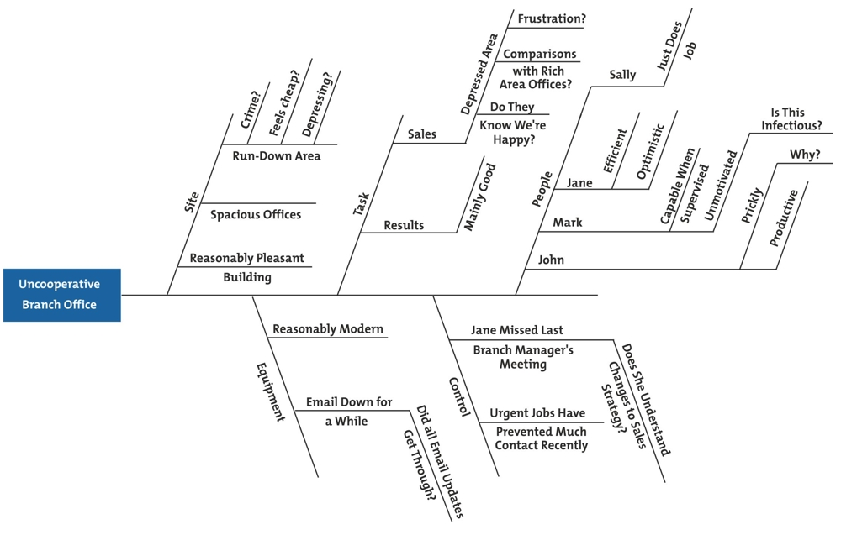Show these possible causes as shorter lines coming off the "bones" of the diagram. Where a cause is large or complex, then it may be best to break it down into sub-causes. Show these as lines coming off each cause line.

*For each of the factors he identified in step 2, the manager brainstorms possible causes of the problem, and adds these to his diagram, as shown.*

* + - Step four: Analyze your diagram
      * By this stage you should have a diagram showing all of the possible causes of the problem that you can think of.
      * Depending on the complexity and importance of the problem, you can now investigate the most likely causes further. This may involve setting up investigations, carrying out surveys, and so on. These will be designed to test which of these possible causes is actually contributing to the problem.
      * Plan actions steps based on results of the root cause analysis
* Identify budget needs for equipment, staffing and other resources. Keep a copy of the cost for such resources with each PIP.
  + - * Pilot test the action(s) prior to launching facility-wide whenever possible. To test the performance improvement plan, use the **PDSA Worksheet For Testing Change**
* Report the results to the QAPI steering committee

**Actions** (Taken from the VA National Center for Patient Safety)

Actions are the critical component of the RCA -- and present challenges for the teams. Strong and well-crafted actions have a clear link to the vulnerabilities and are readily understood. The table below presents some categories and types of actions that might be considered. Stronger actions are viewed as those that are more likely to be successful in accomplishing the desired changes.

Actions must meet the following criteria:

* Address the root cause/contributing factor
* Are specific and concrete
* A cold reader understands and can implement
* Will be tested or simulated prior to full implementation (when feasible)

**Stronger actions**

* Architectural/physical plant changes
* New device with usability testing before purchasing
* Engineering control or interlock (forcing functions)
* Simplify the process and remove unnecessary steps
* Standardize on equipment or process or caremaps
* Tangible involvement and action by leadership in support of patient safety

**Intermediate Actions**

* Increase in staffing/decrease in workload
* Software enhancements/modifications
* Eliminate/reduce distractions (sterile medical environment)
* Checklist/cognitive aid
* Eliminate look and sound alikes
* Read back
* Enhanced documentation/communication
* Redundancy

**Weaker Actions**

* Double checks