**Payor Change Request Coordination Notes**

**Effective 6/6/2022**

**The below process should be followed when identifying a payor change for a current patient. We will no longer utilize email and/or Smartsheets to communicate this information.**

**Two coordination notes have been created in HCHB.**

**Payor Change Request** - This note will be used to communicate when a patient's payor is changing and either the new payor must be added (no discharge and readmit needed), or the patient must be discharged and readmitted under the new payor. The note will be entered by whomever is aware of the upcoming payor change (i.e. Billing Specialist, Team Leader, etc.). This note when entered will be routed to Central Intake & Team Leaders. Central Intake will run eligibility and add the new payor if a discharge and readmission is not needed. If Central Intake is unsure if a patient’s payor change requires a discharge and readmit, an email will be sent to the Billing Department, Chris, and KeShonda to determine.If a discharge and readmit is needed, the Team Leader communicates to the Clinician that a discharge is necessary prior to the payor term date, and then the patient is re-entered under the new payor triggering the new admission workflow. **PLEASE ADD THE PAYOR ID IF AVAILABLE.**

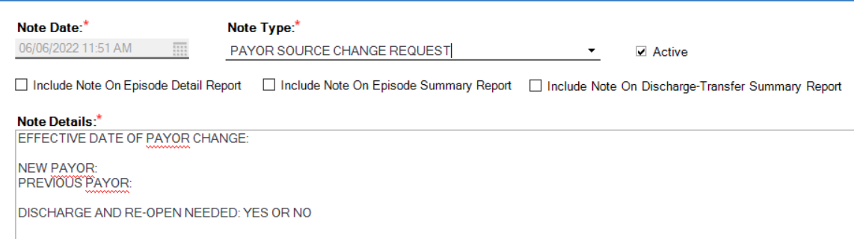

**Payor Change Request - Auth Needed** - This note will be entered by Central Intake and routed to the Central Auth department informing them that authorization must be requested due to a payor change.

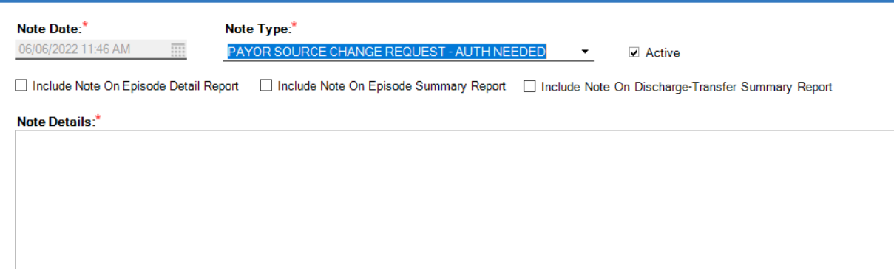

\*\*\*\*\*\*\***PLEASE REMEMBER THAT ADDING A FOLLOW UP COMMENT TO ANY COORDINATION NOTE DOES NOT ALERT ANYONE\*\*\*\*\*\*\***